Integrating Psychological and Social Support in Gestational Surrogacy: A Case Report of Successful Pregnancy Following Uterine Polyp and Miscarriage
Abstract
Background:
Gestational surrogacy is a growing reproductive technique that is applied in cases where people cannot bear a child. The biomedical determinants of success are well-established; however, the psychosocial factors, particularly the effects of organized psychological and social support, are not studied thoroughly.
Case Presentation:
We report the case of a 26-year-old multiparous surrogate with prior uterine polypectomy and one miscarriage who achieved a successful term pregnancy through an integrated psychosocial care model. After early pregnancy loss and implantation failure, she had moderate depressive symptoms (PHQ-9 = 12), which were improved (PHQ-9 = 4) with the help of cognitive-behavioural therapy, the involvement of a spouse, and agency-based counselling. The third embryo transfer led to a viable singleton pregnancy with some minor complications (subchorionic hematoma, asymptomatic bacteriuria), which were treated conservatively. Delivery through elective delivery of the neonate, at 39 weeks, led to a healthy baby (Apgar 9/10). Post-partum assessment of mental stability was done with no depressive symptoms.
Conclusion:
Integrated psychosocial support is a critical component of gestational surrogacy care that improves emotional resilience and pregnancy success.
Keywords: Gestational surrogacy; Psychological support; Social support; Pregnancy outcomes; Psychosocial care model
Introduction
Gestational surrogacy has become an essential reproductive choice for people and couples who have infertility or medical disorders that do not allow them to bear a child. Surrogacy rates in the world have been on the rise, as the use of assisted reproductive technologies is becoming acceptable, and the variety of family-building options is starting to be global (Dumitru et al., 2021). Nevertheless, surrogacy has very tricky ethical, social, and psychological facets that need to be navigated. Although the biomedical factors of surrogacy, including the embryo transfer procedure, obstetric care, and hormonal control, have been well-documented, the psychosocial success factors—especially emotional resilience and social support—are relatively unexplored (Oosbree and Wald, 2023; Herman & Raziel, 2023).
Gestational surrogacy refers to the process where a woman (the surrogate) carries the pregnancy of others or the couple who is not able to have a pregnancy or carry it to completion. Although medical clearance and careful selection are done, in most cases, surrogates face very special psychological challenges during the process. They are anxious about the result of embryo transfer, the fear of pregnancy complications, and a lack of emotional bonds with the fetus, especially in cases of no genetic connection between the surrogate and the child (Dumitru et al., 2021). Emotional strain may be aggravated by the presence of procedural stress related to hormonal stimulation, implantation, and delivery that can affect the outcome of the pregnancy (Dar et al., 2015). Moreover, surrogates tend to experience some uncertainty about the medical and emotional prognosis, which additionally increases their susceptibility to stress, guilt, or depressive symptoms after pregnancy loss.
Evidence-based studies highlight the importance of psychological stability and organized counseling interventions in determining maternal health, as well as perinatal outcomes in the surrogacy process. According to Dar et al. (2015), specific psychotherapy and regular emotional introspection decreased anxiety and enhanced the degree of satisfaction in gestational carriers. These results indicate that psychological support should become a regular part of surrogacy care. The access and organisation of these services, however, are disparately available in clinical and legal contexts, which highlights the need for personalised psychosocial delivery.
In addition to psychological counseling, the social and interpersonal support systems have a significant role to play in defining emotional strength and treatment adherence in the process of surrogacy. Support can be defined in four primary areas: spousal, familial, professional, and agency-based. Spousal support enhances emotional stability and motivation, which in turn leads to adherence to medical advice and improved outcomes in pregnancy (DiMatteo, 2004). A supportive family environment also fosters strong emotional regulation, preventing compliance and stress (Rasool, 2023). Healthcare providers offer professional assistance to ensure informational clarity and empathy, which reduces perceived stress and enhances patient engagement (Shah et al., 2025). Moreover, in medically complicated situations, the psychological pressure is reduced, and the networks of coping are facilitated because the surrogacy agencies usually have organized counseling, coordination, and peer support networks (Hayat et al., 2025). Taken together, these multidimensional supports can lower the level of anxiety, as well as enhance trust and collaboration between the surrogate and the intended parents.
Although an increasing number of psychosocial factors are being considered, case-based evidence of successful surrogacy outcomes associated with structured social and psychological interventions in medically complicated pregnancies is still low. Health issues like polyps of the uterine lining and pregnancy loss in the previous pregnancy pose an even higher degree of emotional distress, which can pose a risk to adherence to the treatment plan and psychological well-being. The current case report is about a surrogate who, despite a history of uterine polyps and miscarriage, had a successful term pregnancy by an integrated care model that incorporates psychotherapy, social reinforcement, and multidisciplinary medical management. This case report provides information on how strong emotional and social support networks can stabilize psychological health, enhance resilience, and optimize obstetric outcomes in complex surrogacy scenarios.
Case Report
Patient Profile
A 26-year-old Caucasian female who lives in Texas, and has a gestational age of 5 para 3013, was placed as a gestational carrier in a licensed surrogacy agency. Obstetric history consisted of three-part vaginal births and one spontaneous pregnancy loss. Her first successful surrogacy (2021) had an uneventful vaginal delivery. No remarkable medical history; spinal surgery was done. She denied tobacco, alcohol, and recreational use of drugs. The family history played an important role in the father's hypertension. The reason she chose surrogacy was selfless. Psychological testing revealed that she was emotionally stable, had sufficient coping skills, and a strong and well-developed social support system.
Pre-Surrogacy Screening and Initial Management
Transvaginal ultrasonography identified a 4 cm endometrial polyp, which was excised via hysteroscopic polypectomy. Recovery was uneventful, and she was medically cleared for embryo transfer. Psychological screening showed no depressive or anxiety symptoms. Despite adequate preparation, she reported procedural anxiety related to implantation outcome. The surrogacy agency initiated structured cognitive-behavioral sessions emphasizing relaxation and adaptive coping techniques.
First and Second Embryo Transfers
The first embryo transfer resulted in conception; however, an ultrasound at 12 weeks confirmed fetal demise. The patient reported guilt and depressive symptoms (PHQ-9 = 12/27). The agency psychologist initiated psychotherapy and cognitive restructuring. A second embryo transfer, performed three months later, resulted in implantation failure. The patient demonstrated reduced motivation but denied suicidal ideation or functional impairment. Multidisciplinary support, including spousal counselling, agency case management, and intended parent communication, was implemented. After four sessions of structured CBT and reinforcement therapy, the mood stabilized (PHQ-9 = 4/27).
Successful Pregnancy and Clinical Course
The third embryo transfer achieved intrauterine gestation. At 12 weeks 3 days, ultrasound demonstrated a viable singleton fetus (FHR 158 bpm) with a small subchorionic hematoma; pelvic rest was advised. Laboratory results: blood group O+, rubella immune, HIV/RPR/HBsAg negative, normal CBC and urine culture. Carrier screening (Horizon®) and noninvasive prenatal testing (Panorama®) were unremarkable, confirming a low-risk female fetus. Throughout the first trimester, the patient remained clinically stable and adherent to counseling. A psychological review documented a euthymic mood and good insight.
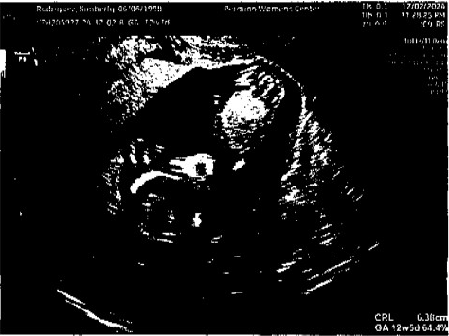
Figure 1. First-Trimester Ultrasound Images. First-trimester ultrasound demonstrating a viable intrauterine singleton gestation at 12 weeks 3 days (CRL 6.31 cm, FHR 158 bpm). Normal yolk sac and amniotic cavity noted.
Mid-Pregnancy Course
A follow-up ultrasound at 14 weeks and 4 days showed resolution of the hematoma and normal fetal growth (FHR 144 bpm). At 17 weeks 4 days, mild asymptomatic bacteriuria was detected and treated with oral antibiotics. A detailed anatomy scan at 20 weeks 6 days revealed a structurally normal fetus, an anterior Grade I placenta, and normal amniotic fluid volume (EFW 329 g; 36th percentile). The surrogate reported normal appetite, adequate sleep, and no affective symptoms (PHQ-9 = 3/27, GAD-7 = 2/21). Vital signs during the second trimester remained stable: BP 105–113/70–79 mmHg, HR 88–99 bpm, weight 187–197 lb. Clinical examinations consistently showed a soft, non-tender abdomen, closed cervix, and appropriate fetal growth.
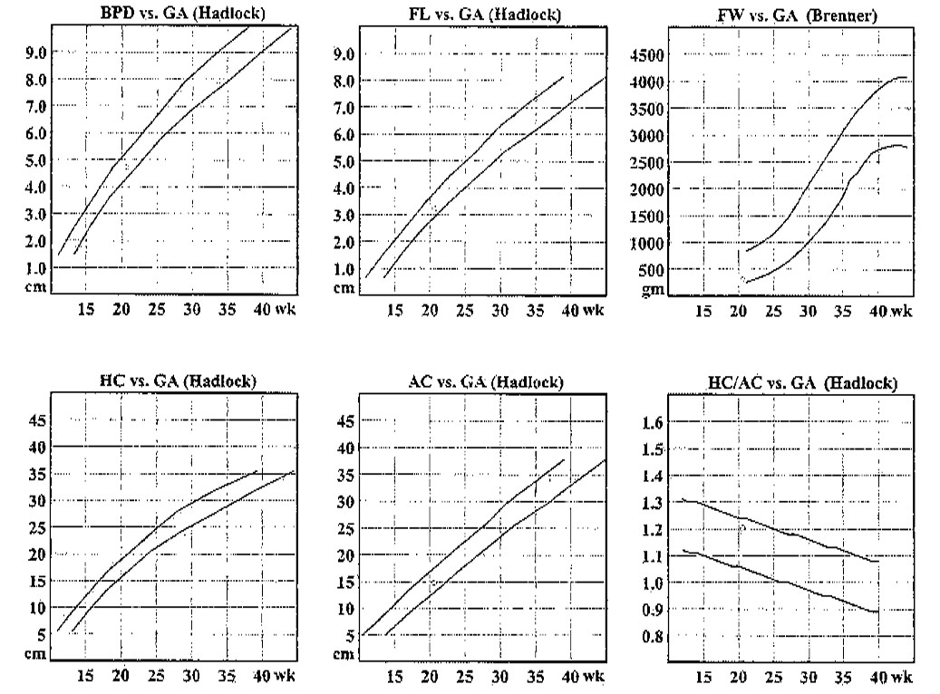
Figure 2. Fetal Growth Charts. Fetal biometric growth curves (Hadlock standards) demonstrating biparietal diameter (BPD), femur length (FL), fetal weight (FW), head circumference (HC), and abdominal circumference (AC) consistent with gestational age throughout pregnancy.
Peripartum Course and Delivery
At 39 weeks, elective induction was initiated for scheduling convenience and a favorable cervical status. After 24 hours of oxytocin infusion, cervical dilation was arrested at 4 cm. The patient exhibited acute procedural anxiety related to cesarean delivery. After multidisciplinary counseling involving the obstetrician, psychologist, and case manager, she consented to surgery. A live female neonate was delivered via lower-segment cesarean section (Apgar 9/10). Estimated blood loss was within normal limits. Postoperative recovery was uncomplicated.
Post-partum Course
Follow-up on postoperative indicated good vitals, wound healing, and no febrile morbidity. Psychological tests revealed normal affect and the absence of depressive or anxiety symptoms on day 2 of the post-partum period (PHQ-9 = 2/27). During the follow-up visits, the surrogate did not report any complaints of poor appetite, energy, or sleep at two and six weeks. The wound healed well, and uterine involution was complete. She continued to do post-surrogacy counseling and was in good contact with the targeted parents. No post-partum depression, anxiety, or post-traumatic stress symptoms were detected.
Discussion
The case provides the example that a combination of structured psychological and social support can be valuable to achieve a successful outcome of gestational surrogacy despite the presence of previous uterine pathology (endometrial polyp) and early pregnancy loss. Although a lot of the literature on surrogacy deals with the biomedical issues of embryo transfer, hormonal regimes, and obstetric surveillance, less is recorded of the psychosocial issues, particularly in medically complex surrogacy. The intentional incorporation of cognitive-behavioural therapy (CBT) sessions, agency-based coordination, spousal/family support, and regular psychological checks in this surrogate could have helped stabilize emotional distress and facilitate resilience, which subsequently likely contributed to an increase in medical adherence and obstetric outcomes.
At first, the psychological sphere: Surrogates experience certain emotional pressure not only the typical concerns of pregnancy (implantation, fetal viability, motherhood) but also an extra layer of pregnancy carrying a child to another couple, child abandonment, and possible detachment dilemmas (Dumitru et al., 2021). It has been revealed that the rates of depressive symptoms are higher among gestational carriers, particularly in the conditions of low social support, secrecy of the surrogacy process, or emergence of negative attitudes of families or communities (Lamba et al., 2018; Riddle, 2022; van Oosbree and Von Wald, 2023). In our example, the surrogate also experienced moderate symptoms (PHQ-9 = 12) that caused the need to intervene after the first trimester fetal death, followed by an implantation failure. The initial counselling sessions enabled her to work through guilt, keep participating in the protocol, and motivate her again to continue with the next cycle.
Theories of psychology of self-efficacy, stress-buffering, and resilience are applicable in this case. Notably, greater perceived self-efficacy during pregnancy is conditionally associated with lower indicators of prenatal stress, and the mediation between the two is facilitated by resilience and social support (Wang et al., 2023). Our surrogate had her psychological assessment ensured with well-developed coping skills and a supportive network that was used by the CBT programme of the agency to reinforce her inner coping abilities and, as a result, probably alleviated the effect of stress on behaviour and physiological levels (such as an example of better compliance with bed-rest/implantation precautions, rest of the pelvis after the hematoma, antibiotic treatment of the bacteriuria).
Second, the social support dimension: Multiple studies have shown that a high level of social support during pregnancy is associated with better obstetric results, increased life satisfaction, and reduced anxiety/depression. For example, a prospective study of 129 low-income pregnant women found that the superiority of support (in terms of quality and network size) correlated with positive labor progress, increased Apgar scores, and reduced post-partum depression rates (Collins et al., 1993). The other meta-analysis yielded similar findings, indicating that higher social support was associated with lower childbirth fear (Alizadeh-Dibazari et al., 2025). Relating to the case of surrogacy, in a quantitative study, surrogates reporting a lower level of social support, concealing their status of surrogacy, or receiving criticism were more likely to be depressed after giving birth (Lamba et al., 2018). Our patient was supported by several levels of social support, including spousal/partner interaction, family stability, agency-related coordination, and open communication with the targeted parents. This likely enhanced her sense of belonging, confidence in the process, and a lesser degree of relational ambiguity, aspects that could have contributed to psychological security and medical compliance.
Third, psychosocial, obstetric/medical management interaction: Even though the surrogate had a uterine polyp (4 cm) removed and a previous miscarriage, the result of this third embryo transfer was a successful term birth. We hypothesize that the psychosocial support could have helped the surrogate to better cope with medical complications (small subchorionic hematoma, asymptomatic bacteriuria), remain calm during the induction, and acclimate to the decision to make a caesarean section upon cervical arrest with a lower anxiety level. Reduced levels of anxiety and stress can lead to decreased adverse physiological outcomes, such as increased cortisol and vascular responsiveness, which may play a role in fetal development or placental performance. Although it cannot be established that medical care and psychosocial interventions have a direct causal relationship, they constitute a biopsychosocial synergy that was likely a contributing factor.
Another lesson of this case is that a structured psychological-social protocol should be adopted by the surrogacy programmes, not only the baseline screening procedure, but continuous monitoring during pregnancy, and after delivery. This is supported by the literature: previous research concluded that psychological screening and support before, during, and after surrogacy are indicated (Van Den Akker, 2007). Considering the more significant issues that have been predicted in the population of surrogacy, like the greater likelihood of developing mental illnesses after childbirth (Riddle, 2022; Velez et al., 2025). Moral and clinical imperatives dictate that the standard of care should be psychosocial scaffolding.
This example contributes to the new body of evidence since it reports positive outcomes in a medically complex surrogacy case with extensive psychosocial integration. It opens up new studies, such as prospective studies comparing surrogates who receive and do not receive structured psychosocial support, focusing on outcomes including pregnancy success (implantation rate, miscarriage, obstetric complications), psychological well-being (PHQ-9, GAD-7, resilience scales), and relational satisfaction. It is also implied that such variables as self-efficacy, perceived social support, and resilience should be included in surrogacy outcome registries or clinical trials.
Pragmatically, a few key lessons emerge. To begin with, this strong support network and ability to cope properly in this surrogacy agency were identified correctly due to the importance of early determination, not only of medical clearance but also of psychological preparation and social support mapping. Secondly, with specific psychological interventions (CBT anxiety/guilt, structured sermons after setbacks), the motivation and emotional balance can be preserved, as observed in the case where the PHQ-9 of the surrogate improved to 4 after the final embryo transfer and to 12 before the final embryo transfer. Thirdly, agency case management should be utilized to facilitate transparent communication among the surrogate, intended parents, and the care team, thereby fostering trust and reducing the likelihood of surrogate isolation. Fourthly, monitoring affective symptoms during pregnancy and in the post-partum phase allowed for the early detection of risk (although there were none in this case), which could be protective.
Limitations:
This is a single-case report, and therefore generalisability is restricted. The effect of psychosocial support cannot be separated from other factors (previously successful pregnancies of the surrogate, good physical health, medical clearance following polypectomy, and quality of the embryos). Additionally, most psychosocial interventions were provided in a real-world agency setting, rather than a controlled trial. However, the comprehensive description of the psychological measures (PHQ-9, GAD-7) and network of social support is value-added.
Finally, in the case of gestational surrogacy, particularly as in the case of medically or obstetrically complicated young carriers, the combined strategy that incorporates systematic psychological counselling, adequate social support, agency coordination, and multidisciplinary obstetric care can improve the well-being and increase the probability of a desirable outcome. Surrogacy programs should incorporate psychosocial protocols into their biomedical pathways. Further systematic research is warranted to assess the impact of such integrated care models.
Conclusion
The case highlights the importance of psychological and social support, which leads to positive results in gestational surrogacy, especially in women carriers with a history of obstetric complications. A combination of the calculated use of cognitive-behavioural therapy, coordination of agencies, and good interpersonal networks stabilized emotional well-being and permitted medical adherence during pregnancy. Biopsychosocial intervention, incorporation of family involvement in surrogacy programs, and multidisciplinary obstetric care should be viewed as the best practices in surrogacy programs. The broader implementation of such integrative care frameworks may enhance surrogate well-being, improve pregnancy outcomes, and establish a benchmark for ethical and holistic reproductive care.
REFERENCE
Alizadeh-Dibazari, Z., Maghalian, M., & Mirghafourvand, M. (2025). The relationship between perceived social support and fear of childbirth in pregnant women: A systematic review and meta-analysis. BMC Psychology, 13(1), 709. https://doi.org/10.1186/s40359-025-03047-7
Collins, N. L., Dunkel-Schetter, C., Lobel, M., & Scrimshaw, S. C. (1993). Social support in pregnancy: Psychosocial correlates of birth outcomes and postpartum depression. Journal of Personality and Social Psychology, 65(6), 1243–1258. https://doi.org/10.1037//0022-3514.65.6.1243
Dar, S., Lazer, T., Swanson, S., Silverman, J., Wasser, C., Moskovtsev, S. I., Sojecki, A., & Librach, C. L. (2015). Assisted reproduction involving gestational surrogacy: An analysis of the medical, psychosocial and legal issues: experience from a large surrogacy program. Human Reproduction, 30(2), 345–352. https://doi.org/10.1093/humrep/deu333
DiMatteo, M. R. (2004). Social support and patient adherence to medical treatment: A meta-analysis. Health Psychology, 23(2), 207–218. https://doi.org/10.1037/0278-6133.23.2.207
Dumitru, A. E., Gică, C., Iordăchescu, D. A., Panaitescu, A. M., Peltecu, G., Botezatu, R., & Gică, N. (2021). Gestational surrogacy. Medical, psychological and legal aspects. Romanian Journal of Legal Medicine, 29(3), 323–327. https://doi.org/10.4323/rjlm.2021.323
Herman, H. G., & Raziel, A. (2023). Gestational surrogacy. In D. K. Gardner, A. Weissman, C. M. Howles, & Z. Shoham, Textbook of Assisted Reproductive Techniques (6th ed., pp. 813–818). CRC Press. https://doi.org/10.1201/9781003268611-72
Lamba, N., Jadva, V., Kadam, K., & Golombok, S. (2018). The psychological well-being and prenatal bonding of gestational surrogates. Human Reproduction, 33(4), 646–653. https://doi.org/10.1093/humrep/dey048
Rasool, A. (2023). The role of family in fostering mental health: Nurturing practices and their long-term effects. Journal Of Business, It, and Social Science, 2(1), 1–3. https://doi.org/10.51470/BITS.2022.01.01.01
Riddle, M. P. (2022). The psychological impact of surrogacy on the families of gestational surrogates: Implications for clinical practice. Journal of Psychosomatic Obstetrics & Gynecology, 43(2), 122–127. https://doi.org/10.1080/0167482X.2020.1814729
Sultan Shah, Syeda Safa Tahoor, Zarrukh Sardar, Maida Gul, & Muqaddas Anwar. (2025). The role of perceived social support in building resilience among individuals with chronic illnesses: Impacts on emotional well-being and coping with disease-related stress. The Critical Review of Social Sciences Studies, 3(1), 977–984. https://doi.org/10.59075/q8ceyp85
Van Den Akker, O. B. A. (2007). Psychological trait and state characteristics, social support and attitudes to the surrogate pregnancy and baby. Human Reproduction, 22(8), 2287–2295. https://doi.org/10.1093/humrep/dem155
van Oosbree, A., & Von Wald, T. (2023). Gestational surrogacy and ethical considerations. South Dakota Medicine: The Journal of the South Dakota State Medical Association, 76(2), 72–75.
Velez, M. P., Dayan, N., Vigod, S. N., Buckett, W., Flatt, S., Shellenberger, J., & Ray, J. G. (2025). New-onset mental illness among gestational carriers. JAMA Network Open, 8(7), e2523428. https://doi.org/10.1001/jamanetworkopen.2025.23428
Wang, Y., Gu, J., Zhang, F., & Xu, X. (2023). The mediating role of social support and resilience between self-efficacy and prenatal stress: A mediational analysis. BMC Pregnancy and Childbirth, 23(1), 866. https://doi.org/10.1186/s12884-023-06184-2

